# Business Case

**Date: June 20, 2014 Prepared by:**

1. **Introduction/ Background**

ACME Corporation established in 1922, is the global leader in unique tools and weapon used by cartoon villains. ACME has perfected the mail order process for distributing their products. However, with the development of e-commerce, they increasingly lose in market share due to their old ordering and internal distribution system. ACME has offices in Edmonton (HQ), testing facilities Rachel, Nevada, and manufacturing centers in Hyderabad, India and GuangMing, China. The systems within these four offices are not compatible in some case and in other cases are compatible but outdated. The goal of CEO Chuck Jones is to “have the entire organization completely connected, on a uniform platform using the latest technology.” They would like to unveil their company to the online community, make their products available anytime and anywhere. ACME would like to have a PC and Network infrastructure, Server infrastructure, Security needs, Intranet, DMZ and e-commerce solution and Web presence.

1. **Business Objective**

The objective is to have the entire organization connected on a uniform platform using the latest technology. They would like to unveil their company to the online community, make their products available anytime and anywhere to anyone. Jones said “our market is the world!”

1. **Current Situation and Problem/ Opportunity Statement**

The current situation with the current systems is that they are not integrated with each other. The systems within these four offices are not compatible in some case and in other cases are compatible but outdated. Only the headquarters in Edmonton has internet connection. The company only has one database server in Edmonton running SQL 7.0 on Windows 2000 for inventory control and accounting. Four offices do not have Uniform desktop environment (Windows 7 Pro).

1. **Critical Assumption and Constraints**

The proposed integration may take longer than expected and the cost may increase depending on the amount of resources needed to support the project. The new system should require minimal technical support. It must be easily accessible by all the different offices.

1. **Analysis of Option and Recommendation**

With our analysis of current operation system, there are three options for AMCE: 1) do nothing, keep current system; 2) purchase common management software; 3) design new specialized system using mostly existing software and hardware. We would recommend this project because the current system can be improved significantly to benefit the company and the customers interacting with the system.

1. **Preliminary Project Requirements**

The main features of the project are that all four offices are connected with each other and a new web application is created to interact with customers. The requirements for project will be: computers, Internet connectivity, uniform platform (Win 7 Pro), database server, firewalls, DMZ/ e-Commerce solution and web presence.

1. **Budget Estimate and Financial Analysis**

The budget estimate and financial analysis provides an approximate cost of the project to be $2 million and the financial analysis is displayed in Cost Management.

1. **Schedule Estimate**

The schedule is estimated to take approximately 1year to fully complete the project. But there is some flexibility in the schedule. The WBS and Gantt chart will show the project schedule structure.

1. **Potential Risks**

There are several risks involved with the project, such as the lack of interest in new system by company and customers and technical risks in database software. The main business risk is investing the time and money into the project and not realizing the projected benefits.

# Integration Management

To make sure all methodologies stated below will be used to keep the project on course.

Observation and conversation

Each project team will be interacting with their team leader at a consistent basis to receive feedback and to propose ideas that project manager can use to enhance and make the system better on the whole. A project manager will observe and interact with each team leader and provide suggestions on how to improve the task. The interaction among team, team leader and project manager will affect the quality of work .

Conflict management

Conflict management will used by every individual involved with project. This will be done through a status report. The status reports will be reviewed by team leader who then also provide additional statuses. All status reports will be send to project manager. If there were major issues with a team, a team discussion will be held among team members, team leader and project manager to discover a solution.

Issue log

With the conflict management, project managers will keep issue logs to document, monitor and track issues with status resolved and unresolved to push the team to work effectively. The project manager will analyze the issue and decide whether he/she will get involved in the issue or not. If the issue were not relevant or high priority, he/she will assign a target date for the team leader to resolve the issue.

# Scope Management

|  |
| --- |
| **Project Title:** **ACME Management System**  **Date:** June 20, 2014 **Prepared by:** |
| **Project Justification:**  ACME requests this project to connect all four offices together with corresponding firewalls. If all offices have a uniform desktop environment( Win7 Pro), they would be better integrated and better communicate with each other. The company also like to create a website for its products using latest technology and design. |
| **Product Characteristics and Requirements:**   1. Pc and Network Infrastructure   The ratio of PC to Employees would be 1:1. Four offices are full connectivity to the internet using Gigabit switched Ethernet. All offices should have a standard PC desktop platform using uniform desktop environment ( Win 7 Pro).   1. Server infrastructure   The database server is available for each office. It should use industry standard platform like Enterprise Linux or Microsoft Server 2008. It need to migrate data from SQL7.0.   1. Security needs   There should be enterprise class firewalls for each office and DMZ for HQ. There should be VPN capability available between four offices.   1. Intranet   All current paper forms and communications would be available on Intranet. Inside sales staff would have access to web based order and inventory system from desktop.   1. DMZ/ E-commerce solution   All web traffic destined for the e-Commerce gateway will be routed to servers behind the firewall. Web server will have real-time connection to the inventory database. Pick and shipping instructions will be generated by the successful customer transaction.   1. Web presence   The company also like to create a website for its products using latest technology and design. |
| **Summary of Project Deliverables**  **Project management-related deliverables:** business case, charter, team contract, scope statement, WBS, schedule, cost baseline, status reports, final project presentation, final project report, lessons-learned report, and any other documents required to manage the project.  **Product-related deliverables:**   1. Inception Document for website application 2. Elaboration Document for website application 3. Construction for website application 4. Hardware Components 5. Implementation |
| **Project Success Criteria:**  Our goal is to complete this project within 1year for no more than $2 million. Moreover, not going over $ 2 million and being able to earn the staffs' satisfaction in using the new system is the major factor in this project's success. This project will maintain data in real time. Communication between four offices will be quick and easy. Organization's files and form will be available for full access over the intranet. Online sale application will greatly facilitate customers. |

# Work Breakdown Structure (WBS)

**Date:** June 20, 2014 **Prepared by:**

1. **Inception document ( web application)**
   1. Vision
      1. Stakeholders and their need
      2. Actors and their goals
   2. Software Requirements Specification
      1. Use Case Specifications
         1. Use Case Model
      2. Supplementary Specification
   3. Software Development Plan
      1. Risk List (initial)
      2. Requirement Ranking List
      3. Iteration Plan
   4. Software Architecture Document
      1. Factor table
      2. Use Case View
      3. Development View
   5. Business Case (Initial)
      1. Business Bid
      2. Economic Gains
2. **Elaboration Document ( web application)**
   1. Vision
   2. Glossary
   3. Software Requirements Specification
   4. Domain Model
   5. Design Model
      1. Use Case Realization Specification
         1. Diagrams
         2. Design Class Diagram
      2. Data Model
   6. Deployment Model
   7. Implementation Model
   8. Test Model
   9. Software Development Plan
   10. Software Architecture Document
       1. Factor table
       2. Architectural Decisions (Technical Memos)
       3. Use Case View
       4. Logical View
       5. Data view
       6. Implementation view
       7. Deployment View
   11. Business Case (Initial)

1. **Construction( web application)**
   1. Presentation layer
   2. Business logic layer
   3. Data access layer
   4. Database
   5. Documentation
      1. Document presentation layer
      2. Document BLL
      3. Document DAL
      4. Document Database
   6. Test prototypes for functionality
2. **Hardware Components**
   1. Standard PC desktop platform
   2. Servers are installed and running with enterprise database software
   3. Firewall and DMZ are installed
   4. VPN capability is running
   5. Full internet connectivity
3. **Implementation**
   1. Improvements are running and functional
   2. Improvements are tested to full extend
   3. Demonstration of system and training is provide
   4. Benefits and employees' satisfaction are received

# Time Management

**Gantt Chart**

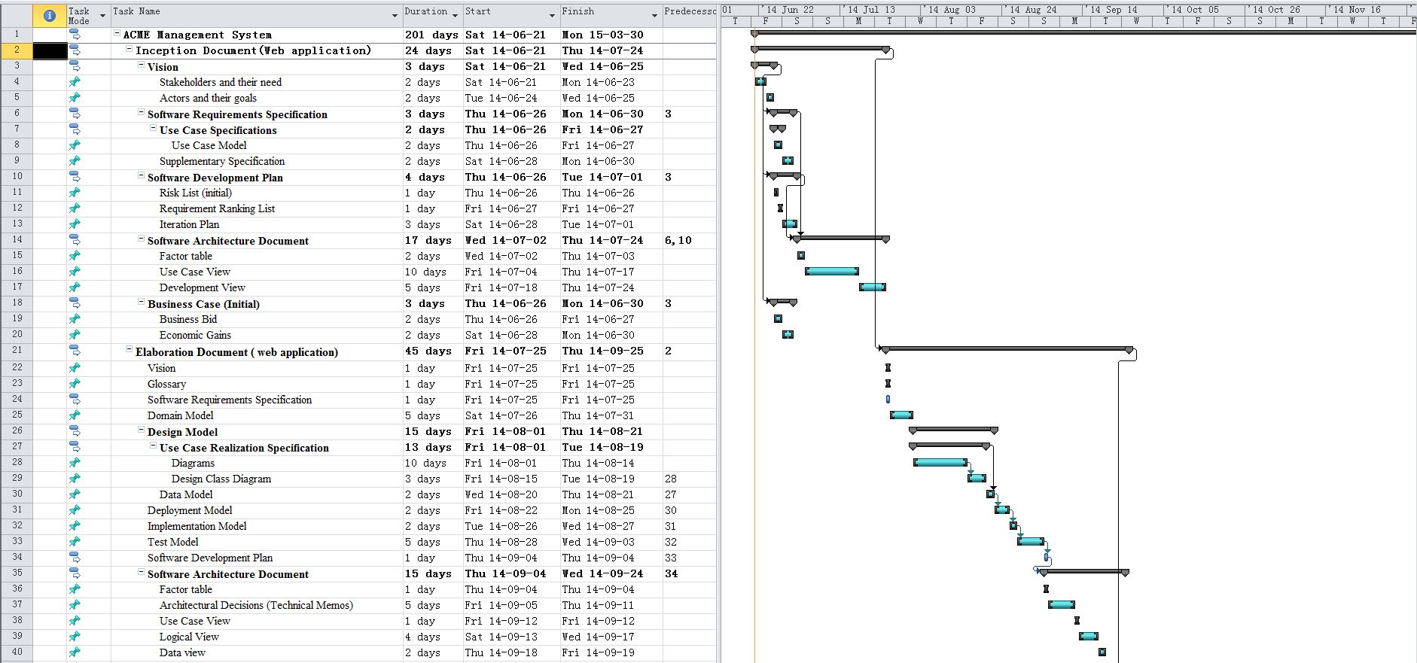

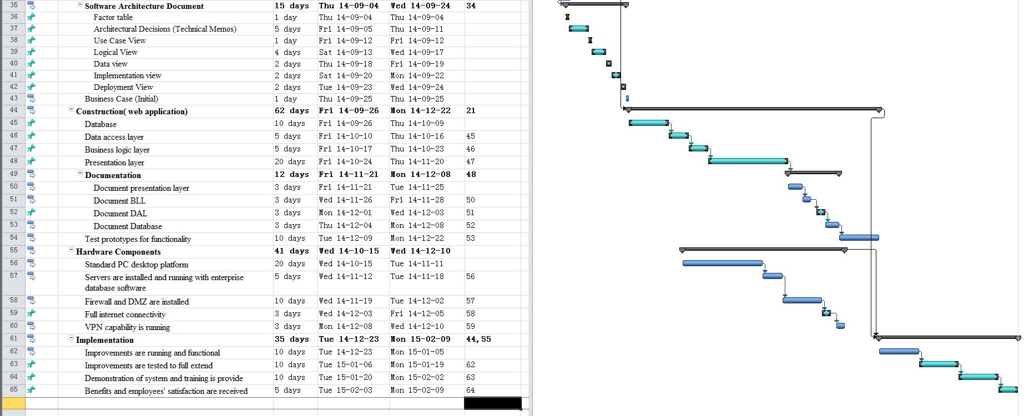

# Cost Management

**ACME Management System Project Cost Estimate**

**Date:** June 20, 2014 **Prepared by:**

|  |  |  |  |  |  |
| --- | --- | --- | --- | --- | --- |
|  | # Units/Hrs. | Cost/Unit/Hr. | Subtotals | WBS Level 1 Totals | % of Total |
| WBS Items |  |  |  |  |  |
| 1. Project Management |  |  |  |  |  |
| 1.1 Project manager | 250 | $100 | $25,000 | $103,956 | 5.35% |
| 1.2 Project team members | 150 | $55 | $8,250 |  |  |
| Contractors (10% of software development and testing) |  |  | $70,706 |  |  |
| 2. Hardware |  |  |  | $313,100 | 16.13% |
| 2.1  Computers with Win 7 Pro(Dell, HP, or Lenovo) | 350 | $750 | $262,500 |  |  |
| 2.2  Gigabit Switched Ethernet | 4 | $900 | 3,600 |  |  |
| 2.3  Enterprise class firewalls | 4 | $8,500 | $34,000 |  |  |
| 2.4  DMZ | 1 | $13,000 | $13,000 |  |  |
| 3. Software |  |  |  | $757,500 | 39.03% |
| 3.1 Licensed software | 350 | $450 | $157,500 |  |  |
| 3.2 Software development |  |  | $600,000 |  |  |
| 4. Testing (10% of total hardware and software costs) |  |  | $107,060 | $107,060 | 5.52% |
| 5. Training and Support |  |  |  | $335,900 | 17.31% |
| 5.1 Trainee cost | 100 | $500 | $50,000 |  |  |
| 5.2 Travel cost | 12 | $3200 | $38,400 |  |  |
| 5.3 Project team members | 4500 | $55 | $247,500 |  |  |
| 6. Reserves (20% of total estimate) |  |  | $347,703 | $323,503 | 16.66% |
| **Total project cost estimate** |  |  |  | $1,941,019 |  |

# Quality Management

**Awareness and training:**

* Investing the time to make sure project team understands the importance of quality and what its role is in making sure to produce the quality result.
* Using pre-existing templates and checklists to manage certain aspects of work.
* Performing walk-troughs and inspections on deliverable components.

There also will be a process developed to make sure that all tasks are completed to the best of our expectations. The following demonstrates how each task will be evaluated.

1. There are iterations during each phase of project and milestones will be assigned.
2. After teams have completed the assigned task(s), they will present it to the team leader.
3. The team leader will assess the documents(s) and verify all the information to be valid. If document(s) does not pass evaluation, it will be returned to the team to fix errors and rebuild it. Upon validation, the team leader will send the document(s) to the project manager.
4. The project manager will re-look the document(s). If the document(s) does not achieve his/her expectation, the project manager will return it back. Otherwise, the project manager will present it to the stakeholders. Later, the stakeholders will provide feedback and suggestions to improve the project.
5. These feedback will be sent back to the team leader. Later, the team leader will discuss the feedback and suggestions with the team members.
6. The project teams will review the feedback and make the suggested changes. They will then re-send new document(s) with suggested changes back to team leader.
7. Repeat from steps 1 to 6.

# Human Management

# Communication Management

**Prepared by: Date: June 21, 2014**

**1. Introduction**

The project teams will communicate within each assigned team. Each team will report its discussion and finished assigned work to its team leader. Each team leader will make main decision for each project team. The team leader will sent all documents to the project manager and get responds from him. The project manager will present all collected documents to stakeholders to keep the stakeholders up to data on the progress of the project.

**2. Collection and filing structure for gathering and storing project information**

The collection and filling structure will be don on Microsoft OneDrive service. All people involved with the project can pull down and upload data as they work on the project.

**3. Distribution structure (what information goes to whom, when, and how)**

The distribution structure will be generated by the project manager. He will develop a set of format as how information id delivered, sent and managed by each team member. Having all major documents go through by project manager before sending to the stakeholder.

**4. Format, content, and level of detail of key project information**

The format and the level of detail of key project information will follow standard that set by the project manager. If the information is not formatted in that standard, it will have to be reviewed and done again to be valid to be send to the stakeholder.

**5. Production schedule and resources for producing key project information**

The production schedule and resources are determined and gathered before project teams begin project. Each team discusses and determines for their assigned tasks what resources are required and production schedule to deliver the task on time.

**6. Technologies, access methods, and frequency of communications**

The technologies used will be the latest, such as Visual Studio 2013, SQL Server 2008 as required, AJAX and Silverlight. The access method is Microsoft OneDrive service which allow team member view, download or upload data. The frequency of communication between teams and the project manager will be every two weeks. There also will be a internal chat room system(SPARK) for all project members to use if they need to discuss something.

**7. Method for updating the communications management plan**

The method will be for the project manager to receive feedback from project team and update the plan as suggestions arise.

**8. Escalation procedures**

The team leader will take control of an issue if the consultant cannot solve the problem. All escalation must be documented and managed so there is "no surprise" for any individual involved with the project.

**9. Stakeholder communications analysis**

|  |  |  |  |  |
| --- | --- | --- | --- | --- |
| **Stakeholders** | **Document Name** | **Document Format** | **Contact Person** | **Due Date** |
| CEO Chuck Jones | Iteration Report | Hard Copy | Veenayah | End of Iteration |
| ACME staff | Module XX | Hard Copy  E-Mail | Addison | End of Iteration |
| Users of ACME Online Management System | System V1.0  Manual | Hard Copy  Internet | Jason,  Leo | End of Implementation |
|  |  |  |  |  |
|  |  |  |  |  |
| **Comments:**  **Place titles and dates of documents in e-mail subject and have all recipients acknowledge that they have received the document.** | | | | |

**10. Glossary of terms**

**SPARK:** an internal messenger used for discussions and questions between employees working on the project.

**AJAX:** a group of interrelated Web development techniques used on the client-side to create asynchronous Web applications.

**Silverlight:** an application framework for writing and running rich Internet applications, with features and purposes similar to those of Adobe Flash.

**OneDrive:** a file hosting service that allows users to upload and sync files to a cloud storage and then access them from a Web browser or their local device.

# Risk Management

A risk is an event or condition that, if it occurs, could have a positive or negative effect on a project’s objectives. Risk Management is the process of identifying, assessing, responding to, monitoring, and reporting risks. The Risk Management Plan is created by the project manager in the Planning and is monitored and updated throughout the project.

The project manager working with the project team and project sponsors will ensure that risks are actively identified, analyzed, and managed throughout the life of the project. Risks will be identified as early as possible in the project so as to minimize their impact.

The steps for minimize risk's impact are outlined below.

* Risk identification

Risk identification will involve the project team, appropriate stakeholders, and will include an evaluation of environmental factors, organizational culture and the project management plan including the project scope.

* Risk analysis

All risks identified will be assessed to identify the range of possible project outcomes. All risks identified will be assessed to identify the range of possible project outcomes. Qualification will be used to determine which risks are the top risks to pursue and respond to and which risks can be ignored. The probability and impact of occurrence for each identified risk will be assessed by the project manager.

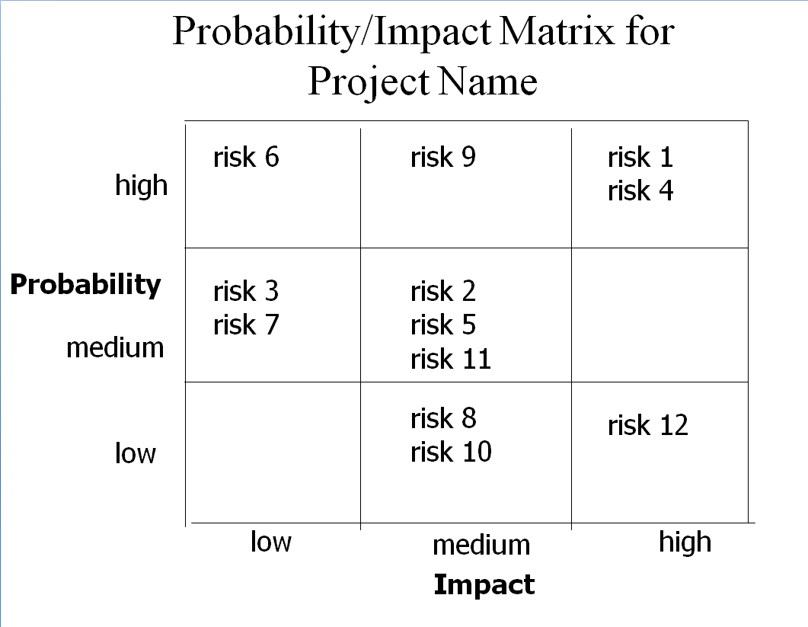

* Risk response planning

Each major risk will be assigned to a project team member for monitoring purposes to ensure that the risk will not “fall through the cracks”.

* Risk Monitoring, Controlling, And Reporting

The level of risk on a project will be tracked, monitored and reported throughout the project lifecycle.

# Procurement Management

# Change Control Plan

**Purpose of The Change Control Plan**

The Change Control Plan documents and tacks the necessary information required to effectively manage project change from project inception to delivery.

The Change Control Plan intended audience is the project manager, project team, project stakeholder whose support is needed to carry out the plan.

**Change Control Process**

The Change Control process establishes an orderly and effective procedure for tracking the submission, coordination, review, evaluation, categorization, and approval for release of all changes to the project’s baselines. The following will demonstrate how the change request is approved and implemented.

1. One of team members including the team leader fill out the change request form. The form then will be send to the team leader.
2. The team leader sent the change request form to the project manager.
3. The project manger review the form and then will call all team leaders and relative stakeholder if it was necessary into a meeting about the change request.
4. During the meeting, they will discuss whether this change request is valid enough to be approved and implemented or not. If it's not, the request will be rejected. Otherwise, the change request is recorded and a notification of the change request is sent to all project teams.
5. This change request will now be handed back to the project manager. The project manager will assign a new task to the team and change certain areas of project plan to place this change.
6. After the implementation of the change, the team will test and verify the change.

# Change Request Template

Change Request Form

**Project Name: ACME Management System**

**Date Request Submitted:**

**Title of Change Request**

**Change Order Number:**

**Submitted by**: (name and contact information)

Change Category: Scope Schedule Cost Technology Other

**Description of change requested:**

**Events that made this change necessary or desirable:**

**Justification for the change/why it is needed/desired to continue/complete the project:**

**Impact of the proposed change on:**

**Scope:**

**Schedule:**

**Cost:**

**Staffing:**

**Risk:**

**Other:**

**Suggested implementation if the change request is approved:**

**Required approvals:**

|  |  |  |
| --- | --- | --- |
| **Name/Title** | **Date** | **Approve/Reject** |
|  |  |  |
|  |  |  |
|  |  |  |
|  |  |  |

# Client Acceptance Form

Client Acceptance/Project Completion Form

**Project Name:____ ACME Management System _______________**

**Project Manager: ________** Veenayah **___________________________**

**I (We), the undersigned, acknowledge and accept delivery of the work completed for this project on behalf of our organization. My (Our) signature(s) attest to my (our) agreement that this project has been completed. No further work should be done on this project.**

|  |  |  |  |
| --- | --- | --- | --- |
| **Name** | **Title** | **Signature** | **Date** |
| Chuck Jones | CEO |  |  |
|  |  |  |  |
|  |  |  |  |

1. Was this project completed to your satisfaction? Yes No
2. Please provide the main reasons for your satisfaction or dissatisfaction with this project.
3. Please provide suggestions on how our organization could improve its project delivery capability in the future.

**Thank you for your inputs.**

# Transference to operations

# Glossary of Terms

**Business case:**

Provides reasoning for initiating a project.

**Scope Statement:**

The Scope Statement describes the scope of the project. It should be high-level but kept accurate.

**Work Breakdown Structure:**

Project is broken down into smaller pars so tasks can be assigned and the project can be managed as a whole.

**Gantt Chart:**

A Gantt chart, commonly used in project management, is one of the most popular and useful ways of showing activities (tasks or events) displayed against time.

**Communication management Plan:**

The Communications Plan describes how communications will be carried out over the course of the project.

**Quality Management Plan:**

The Quality Management Plan defines the acceptable level of quality, which is typically defined by the customer, and describes how the project will ensure this level of quality in its deliverables and work processes.

**Change Control Plan:**

The Change Control Plan describes how the Integrated Change Control process works and who is involved.

**Risk Management Plan:**

The Risk Management Plan describes how risks will be managed throughout the project.

**Project Manager:**

The person who oversees the project and is the main person that controls all areas of the project.

**Deliverable:**

A tangible or intangible object that is produced as a result of developing and completing tasks that are assigned.